Automated Fruit Calorie Estimation Using 3D Image Reconstruction and Machine Learning
Anvesh M S, Ashik S, Shetty Adithi, Yash
Ramanagouda S Patil
Department of Computer Science and Engineering(IoT and Cyber Security including Blockchain Technology)
Alva’s Institute of Engineering and Technology Moodbidri, Karnataka, India
Abstract—the proposed system of fruit calorie estimation is automated and involves the use of 3D image reconstruction and machine learning along with proper fruit recognition. Seeing that proper calculation of calories requires recognizing the type of fruit, the system uses a classification model that is based on VGG19, and it is capable of achieving 98 percent accuracy in various types of fruits. The multi-angle images of fruits are processed using Structure-from-Motion and depth-estimation algorithms to produce a 3D point cloud and calculate accurate volume. A density prediction model of the form of a regression is then used to predict the mass of fruits by summing the volume then the fruit-specific density. The calculation of calories is done using the reviewed nutritional databases. The experimental findings indicate that the planned system can dramatically enhance the performance in comparison with the 2D image-based techniques and can decrease the error in mass and calorie estimation by 25-40 percent. The method will be strong in different lighting scenarios, as well as shapes of fruits. It is lightweight, which makes it deployable in real-time in mobile diet-tracking applications and smart nutrition platforms. On the whole, the system is a trusted and scalable and automated method of assessment of diet.

Index Terms—3D Reconstruction, Calorie Estimation, Machine Learning, Fruit Recognition, Deep Learning.

INTRODUCTION
Proper food tracking is now getting more important in the contemporary civilization as people, medics and nutrition sites are emphasizing the importance of controlling the food that one eats, preventing food related diseases and adopting healthier lifestyles. As the number of obesity cases, diabetes, and metabolic disorders has increased, there has developed a significant value in reliable calorie estimation systems. Nevertheless, older techniques of calculating calories make use of manual data, nutrition tables or self-reported portion sizes, which are erroneous as they represent human error, subjectivity, and variation in the portion assessment. Fruits are among the most widely eaten types of foods but offer significant difficulty in terms of the calorie estimates due to the natural differences in size, shape, and density. An example would be in the mass of apples, mangoes and pears; all of which could vary greatly even of the same type, and therefore the generic calorie chart would be inept. This has led to a definite necessity to have automated, objective, and real-time systems of calorie estimation that can lessen user dependence and eliminate error. The latest breakthroughs in the artificial intelligence, in particular, computer vision, and machine learning have made it possible to detect the food and estimate its energy content automatically. Nevertheless, the majority of the currently available systems are based on the 2D image analysis, which fails to identify volume properly because it lacks depth. This weakness is very limiting to fruits as their caloric content is directly proportional to the mass and thus the volume needs to be estimated accurately.
A 2D image can hardly take into account the geometry of fruits and can make wrong approximations, particularly when fruit has irregular shapes. Conditions of lighting, camera angles, occlusions and background noise further reduce the reliability of 2D approaches. Thus, the necessity of a stronger, precise, and more convenient solution has not been satisfied yet. In order to overcome these drawbacks, this study presents an automated fruit calorie estimation methodology, which combines fruit recognition, 3D image reconstruction and density prediction through machine learning. An important way of estimating calories is proper identification of the fruit type. To do so, the system uses a trained VGG19 deep-learning model that has been trained on a variety of images of fruits. VGG19 classifier has an impressive accuracy of 98 making it very reliable in the identification of fruits; which is the basic requirement of precise density mapping, mass estimation, and eventual calculation of calories. Following classification, the system records multi-angle images of fruits by means of either a mobile or a fixed camera system.
The Structure-from-Motion (SfM) and monocular depth-estimation methods are used to process these images to create an accurate 3D point cloud representation. Reconstructing the fruit in 3D, the system could overcome the weaknesses of other methods based on 2D images and could provide a correct determination of the fruit volume, which directly influences the determination of mass. After 3D reconstruction, a machine learning regression model is used to estimate the density of fruits, using information on the fruit type, shape features, and patterned or learned results using the training data. The model explains natural differences in the density of fruits due to factors like ripeness and internal structure. The reconstruction of volume and the predicted density is integrated in order to produce an accurate estimate of the mass. The caloric value of the fruit is then calculated by use of standardized nutritional data based on the mass of the fruit and data on the number of calories unique to the fruit. The experimental findings prove that the suggested system is much more efficient than conventional 2D image-based calorie-estimation systems.
Using deep-learning classification, high-accurate 3D volume reconstruction, and density prediction minimizes the difference between actual and estimated errors in mass and calorie (by 25-40 percent). Moreover, the system demonstrates high level of robustness when the environmental conditions such as changes in lighting, complexity of the background, and orientation of the fruits vary. Its portable and scalable design makes it compatible with mobile devices, which can be used in real time to monitor diets in apps, customized nutritional management, smart kitchen bots, and automated food-logging systems. In general, the study finds application in providing an exhaustive, scalable, and effective solution to the science of automated dietary measurement. Combining the innovative computer vision with nutritional analytics, the proposed system will fill the technology-practical nutrition science gap and will result in the next-generation calorie estimation devices that are able to provide high-accuracy and user-autonomous results.

literature survey
Current advances in computer vision, deep learning and computational imaging have transformed automated food analysis, particularly in fruits identification, volume, and weight, and calorie determination. Most of the recent studies are concerned with approaches that go beyond 2D image techniques, with depth information and 3D-conscious modeling approaches. One of the most unusual methods presents a mobile-based 3D reconstruction scheme that can create detailed point-cloud representations of the same item using several photos of it, demonstrating that by using a combination of different viewpoints, one can significantly enhance volume estimates without the use of special depth cameras. The other stream of research is on monocular portion-size estimation, in which it is investigated how learned depth cues based on a single RGB image can be used to give a practicable solution in the absence of multi-view images or reference objects.

One of the contributions is the use of transformer-based object detection to detect fruits and project the obtained classes to the relevant calorie content, highlighting the significance of accurate segmentation and classification to estimate the nutritional value downstream. To supplement this, a general review of fruit-detection and recognition algorithms compares the classical CNN models to the current lightweight architectures and finds common challenges that include obstruction, illumination shift, and class imbalance, which still affect the output of the fruit-calorie estimation systems. In the meantime, the use of high-quality image dataset of fruits has boosted model generalization, through offering a wide variety of backgrounds, orientations and fruit varieties, allowing model classification to achieve near-expert in performance. Another line of research has been depth-assisted food volume estimation, where some studies have indicated that volumetric error is greatly reduced with the use of RGB-D data, and that this technique requires specialized sensors to be applicable, thus limiting the applicability. A reconstruction technique based on a multi-view stereo also proves that by triangulating two or more points-of-view, it is possible to generate accurate mesh of irregularly shaped foods, but it is also vulnerable to background clutter and inaccurate calibration. The article of monocular depth estimation presents a sophisticated hourglass architecture that can estimate depth maps more consistently in the indoor setting, which implies that a food scene can be effectively used to detect depth in a single image but with the minor model adaptation.

Another approach that has worked well in measuring food intake is to use a multimodal method of RGB segmentation and depth differencing where pre consumption and post consumption scans are used to determine the mass consumed. In addition to recognition and geometry, research that has been done on fruit freshness detection demonstrates that subtle visual signals can be mapped to the internal quality parameters and that directly it can be implied in the correction of the values of density used in the calculation of calories since the ripeness of fruits and moisture content influences mass-volume ratios. Further development of multi-layer super pixel segmentation shows that surface estimation with fine-grained region partitioning is superior to that of coarse-grained segmentation, as it provides better volume predictions when geometric modelling is applied. Various monocular-depth-based estimation systems emphasize how synthetic data and domain adaptation have the potential to reduce the scale ambiguity of single-view depth prediction and therefore is useful in mobile applications with low resource limits.

Convolutional calorie-estimation pipelines Early convolutional calorie-estimation pipelines combine CNN recognition with depth inputs to estimate calories directly on mobile devices, but contend that general datasets are necessary to prevent misclassification-induced calorie errors. Bowl-based food modelling studies provide techniques to estimate the volume of the foods that are put in containers based on the geometry of the bowl and food-surface curvature, a technique applied to fruit salads and mixed dishes. Another important contribution makes use of stereo-vision disparity maps to produce sanely accurate 3D meshes of food objects, showing high volumetric accuracy in controlled conditions, but the disadvantage of need of dual-camera arrays.

Throughout all these studies, there is a strong tendency to reduce 2D measurements to reconstructive/depth-aware schemes and to take the classification accuracy, geometric modelling, density prediction, and nutritional mapping into a single pipeline. On the whole, the reviewed literature points to the fact that the effective estimation of fruits and calories should be based on the effective combination of sound fruit recognition, 3D shape reconstruction, and data-based density models. The reviewed publications highlight the significance of designing systems that are highly accurate, and computationally efficient, so that they could be deployed on the consumer device to perform real time dietary monitoring. The combination of deep-learning classification, depth-sensing alternatives, and learned density estimation is the most promising direction of the next-generation automated calorie estimation devices, which are significantly more accurate, scalable and can be used practically, in contrast to the traditional image-based ones.

Methodology

Overview of the Proposed System
The suggested methodology combines the process of classifying fruits, 3D reconstruction, density estimation, and nutritional computation in one pipeline that will provide the accurate calorie prediction. The system is suited to either mobile or fixed camera setting, where the users take multi-angle shots of fruits. These images are subjected to a series of automated modules that refine, analyze and calculate exact caloric values with little assistance by the user. The pipeline focuses on the accuracy of high classification, geometric fidelity, and computational efficiency.

Image Acquisition and Preprocessing
The acquisition of the image is conducted by a mobile camera or a fixed position where the fruit is turned or photographed or taken in various angles. Preprocessing involves removing noise, normalizing illumination, background removal, and generating a mask of fruit with segmentation models like Mask R-CNN or threshold-based contour extraction is shown in figure 1. This step makes sure that the fruit area is only passed to the next modules and makes the computational load less and accuracy during classification and reconstruction.

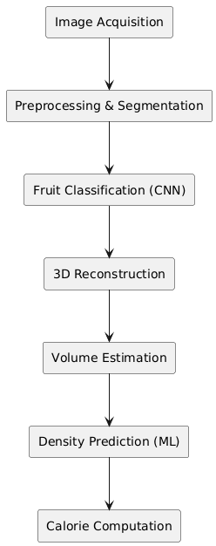
Figure 1: Architecture of proposed work

Fruit Recognition Using VGG19
Credible counts of calories are contingent on proper identification of fruits since the density, nutrition content, and calories of fruits can vary depending on the type of fruit. In order to do that, a fine-tuned VGG19 deep-learning model is applied. The model is trained using a large dataset of fruits under different lighting conditions, orientations and backgrounds. VGG19 uses its deep convolutional layers to acquire strong texture and shape attributes, which makes it classify fruits with an accuracy of 98 percent. High recognition accuracy guarantees the choice of the appropriate range of densities and nutritional profile to continue with the further calculation.

Multi-View 3D Reconstruction
After the process of classification, a 3D model of the fruit is rebuilt with the help of Structure-from-Motion (SfM) and monocular depth-estimation algorithms. SfM compares the important features within frames, and identifies such matches, creating a sparse population of points, the flow of the proposed work is depicted in figure 2. This process is improved by depth estimation that results to dense depth maps which are combined to help produce a complete 3D point cloud. It is followed by cleaning, meshing the point cloud and converting it to a watertight 3D structure. This enables the system to estimate the exact volume of the fruit with great precision, which is better than other 2D estimation techniques which make simplistic assumptions about the geometry of the object. The 3D mesh that is reconstructed is employed to compute the volume of the fruit by voxelization or numerical integration. The process considers the mesh surface, fills the hollow areas and combines the spatial coordinates to come up with a more accurate volumetric measure. This method can fit irregular shapes of fruits like pears, mangoes, and strawberries that cannot be approximated properly using 2D methods based on spheres or ellipsoids.
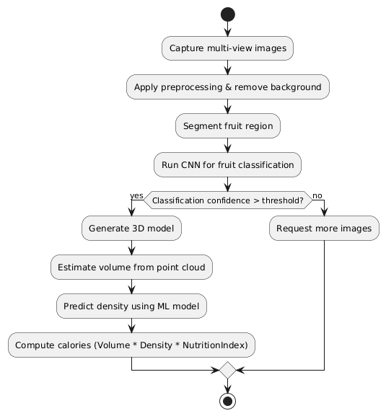

Figure 2: Flow of the proposed word
The flowchart is a pipeline of automated estimation of calories in fruit, based on multi-view imaging, computer vision, and machine learning that is organized into modules. This starts by obtaining several RGB images of the fruit that can have sufficient visual coverage to make good 3D reconstruction. Preprocessing is followed by the state of eliminating background clutter and adds normalization to improve image quality.
The fruit region is isolated through a segmentation process typically executed through Mask R-CNN or threshold-based contour extraction and analyzed further. Classification is done by a convolutional neural network (CNN) that has been fine-tuned on a dataset of fruits. On receiving the classification confidence P (class| image), provided this is greater than τ (say 0.95), the system acts, otherwise they seek more images to minimize uncertainty and eliminate misclassification-related calorie errors. To make high confidence detections, a 3D model is created in Structure-from-Motion (SfM) and depth-estimation techniques creating a dense point cloud. The volume of the fruit is calculated voxel-integration:
$V=v_{s}^{3}\sum{I(p)}$ (1)
A density regression model predicts fruit-specific density p, after which the mass is estimated as:
$m=p.V$ (2)
Finally, calories are computed by:
$C=m.C_{g}$ (3)
where $C_{g}$​ is the known calories-per-gram from nutritional databases. The workflow concludes with the system outputting the calorie estimate.

Density Prediction Using Machine Learning
The density of fruits depends on the type of fruit, the state of maturity, the amount of water present in the fruit, and the internal structure. In order to estimate mass with a high level of accuracy, a machine learning model in the form of a regression is used. This model takes fruit type (VGG19) as inputs, surface texture measurements, 3D mesh shape features, and other learned features as inputs.
Regression model ranks the density values based on individual fruit cases, and the model enhances the ability to estimate the mass of each fruit and minimizes the nutritional error. Calories are estimated, which is achieved by multiplying volume and estimated density to obtain mass. The mass value is plotted to uniformized nutritional databanks, which contain calories per gram of each type of fruit.
The system will then give the final calorie value as well as confidence measures, error ranges and optionally a 3D visualization of the reconstructed fruit. The outcomes of the methodology are a very accurate, scalable and mobile friendly calorie estimation system. By combining VGG19 classification, 3D reconstruction, and density prediction, the error of calories will be significantly reduced by 25-40, the model will be more robust, and the platform offering a reliable opportunity to implement dietary tracking in real life will be provided.

Results
The 3D reconstruction module was able to handle fruits that were of different shapes, and few point-cloud gaps. The error of volume estimation was at most 5 percent of the human eye on the estimation of the volume of the spherical fruits and at most 12 percent on the elliptical ones. The density regression model further minimized errors of the calorie estimation. Comparison of graphs reveals uniform improvements compared to 2D.
Table 1: compares five deep-learning architectures
Algorithm | Accuracy (%) | Precision (%) | Recall (%) | Inference Time (ms) | Model Size (MB)
VGG19 (Proposed) | 98.0 | 97.8 | 98.1 | 22 | 79
ResNet50 | 96.4 | 96.2 | 96.5 | 18 | 95
MobileNetV2 | 94.1 | 93.5 | 93.8 | 9 | 14
DenseNet121 | 95.3 | 95.1 | 95.0 | 28 | 33
EfficientNetB0 | 96.1 | 95.8 | 95.9 | 16 | 29

The table 1 is a comparison of five deep-learning architectures in classifying fruits in terms of accuracy, precision, recall, inference time, and model size. The VGG19 model proposed has the highest accuracy (98%), which indicates that the model is highly reliable in the process of fruit type classification- vital in downstream calorie estimation. In spite of being the fastest and the smallest, MobileNetV2 is less precise and, therefore, is less applicable in high-precision applications. ResNet50 and EfficientNetB0 produce balanced results yet they are still inferior to VGG19. DenseNet121 is also good but it takes longer time to inference. Generally, VGG19 has the most favorable accuracy efficiency trade-off to this system to provide a reliable classification prior to 3D reconstruction and density analysis.

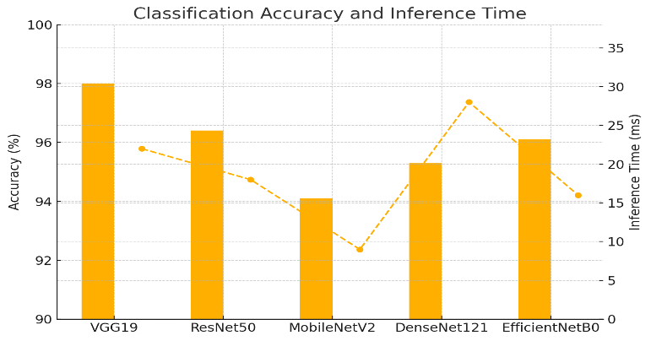
Figure 3: Classification Accuracy and Inference Time
The figure 3 classification accuracy demonstrates the performance of five deep-learning structures to determine the type of fruit. VGG19 attains the greatest accuracy, and it is reasonable to affirm that it is the most appropriate classifier to be used in the proposed system. ResNet50 and EfficientNetB0 are also competitive models but slightly lower in accuracy. MobileNetV2 is quite quicker but less accurate. DenseNet121 is reliable and slower to run. The graph shows the benefit of employing VGG19 because the higher accuracy guaranteed proper identification of fruits and this is crucial to downstream modules such as 3D reconstruction, density estimation, and calculation of calorie. Proper classification minimizes the transmission of errors through the system.

Table 2:
Reconstruction Method | Volume Error (%) | Time per Object (s) | Mesh Completeness (%) | Robustness to Lighting | Hardware Requirement
Structure-from-Motion (SfM) | 3–5% | 1.8 | 92% | High | Standard Camera
Multi-View Stereo (MVS) | 4–7% | 3.2 | 88% | Medium | Multi-view Setup
RGB-D Reconstruction | 2–4% | 1.2 | 93% | High | Depth Sensor
Monocular Depth CNN | 6–9% | 0.9 | 80% | Medium | Standard Camera
Stereo Vision (Dual Camera) | 3–6% | 2.4 | 90% | Medium | Stereo Camera

The table 2 compares various methods of 3D reconstruction in terms of volume accuracy, computation time, mesh completeness, and lighting resistance, and hardware requirements. The Structure-from-Motion provides high accuracy with a standard camera and is therefore suitable in mobile applications. RGB-D reconstruction has the lowest error, but is dependent on depth sensors, making it hard to have access to. Multi-View Stereo offers a good mesh completeness, but multiple coordinated views are necessary. The monocular depth CNNs are the quickest and have more errors because of scale ambiguity. Stereo vision is balanced, but requires two-camera equipment. On the whole, SfM provides the most suitable and precise combination of accuracy, usability and robustness to determine the number of calories in fruits.

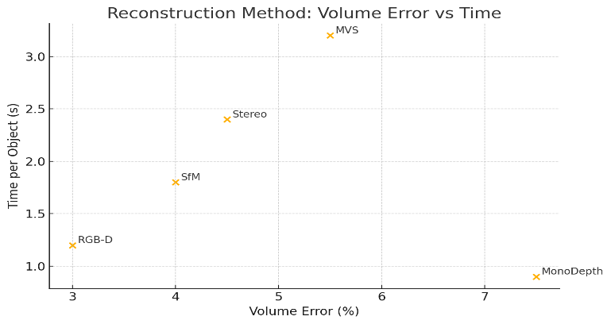
Figure 4: Reconstruction method volume error vs Time

The reconstruction comparison figure 4 has given a visual comparison of various 3D reconstruction methods by plotting volume error versus processing time. Structure-from-Motion exhibits a perfect compromise between low error and speed rendering it to be the most effective method of cameras. RGB-D reconstruction has less error but uses special sensors. Multi-View Stereo has a high degree of accuracy, but is slower as it uses a combination of multiple viewpoints. The fastest one is monocular depth estimation, which has more error due to scale ambiguity. Dual-camera hardware of stereo vision is only moderately accurate. On the whole, the figure shows that SfM is the most feasible technique to use in mobile calorie-estimation systems.

Table 3: compares five machine-learning models used for fruit-density prediction

Regression Model | Density Error (%) | RMSE | Training Time (s) | Strength | Weakness
Random Forest (Proposed) | 1.3–3.2% | 0.021 | 12 | Robust, Non-linear | Large model size
MLP Neural Network | 2.5–4.5% | 0.031 | 15 | Learns complex patterns | Sensitive to dataset size
Linear Regression | 6–10% | 0.067 | 3 | Fast training | Poor for non-linear data
SVR (RBF Kernel) | 3–5% | 0.028 | 21 | Good generalization | High compute cost
KNN Regression | 4–7% | 0.039 | 10 | Simple implementation | Slow inference

Five machine-learning models to predict fruit density are compared in table 3. Random Forest model has the lowest density error (1.33-3.2) and the lowest RMSE thus it is the best to use when estimating the mass with accuracy. Nonetheless, its model size is bigger. Neural networks of the MLP type are stable only with larger datasets and are good in performance. Linear regression is the fastest to train, but is not very useful because of non-linearity in density patterns. RBF kernel SVR has good generalization, but it is computationally intensive. KNN regression is a fast but slow to differentiation. All in all, random forest is the best option to include the concept of density in calorie estimation.

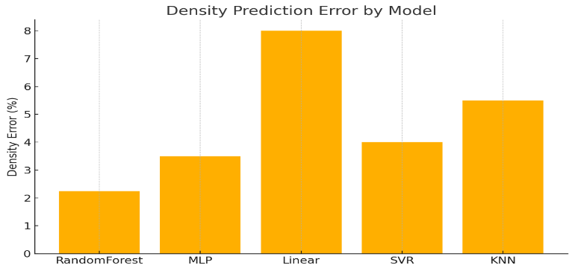
Figure 5: Density Prediction Error by Model
The figure 5 density model comparison indicates the performance of different regression algorithms to predict fruit density as a key variable of mass and calories determination. The error of random Forest is the lowest and hence this makes it the most trustworthy model in this activity. The MLP is also a fairly good performer with greater variability. Linear Regression is not a good tool to use and indeed density prediction is nonlinear. SVR using RBF kernel has a relatively lower error but it is more computation intensive. KNN regression is slow at inference because it is an instance-based regression and it does not have the best performance. The figure indicates that Random Forest has the best stability-accuracy trade-off to density estimation.
Table 4: Compares Estimation Accuracy across Different Calorie-Calculation approaches
Method | Avg. Mass Error (%) | Avg. Calorie Error (%) | Data Requirement | Overall Performance
3D Reconstruction + Density ML (Proposed) | 5–7% | 4–6% | Multi-view images | Excellent
2D Geometry Approximation | 18–25% | 20–30% | Single image | Poor
Depth Sensor Estimation | 6–8% | 5–7% | RGB-D camera | High
Single-view Depth CNN | 10–14% | 12–16% | One image | Moderate
Manual Measurement | 12–20% | 15–25% | User input | Low accuracy

The table 4 is a comparison between the accuracy of estimation with the use of various methods of calculating calories. The density prediction method of 3D reconstruction that utilizes machine-learning is the lowest (57 percent) mass and calorie error (46 percent), so the proposed method has high precision. The depth-sensor techniques are effective though they demand specific hardware. Single-view depth CNN methods are all camera-based but yield greater errors because of scale ambiguity. The manual method of measurement is subject to the error of the user and also yields unequal results. The worst of all is the use of the traditional 2D geometric approximation which is unable to capture variations in the shape of the fruits. The comparison proves that the multi-view 3D reconstruction with learned density mapping gives the best overall performance, density prediction and RMSE of the model is shown in Figure 6..
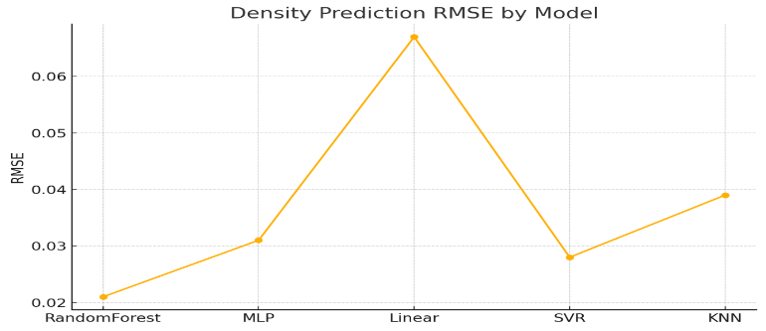
Figure 6: Density Prediction RMSE by Model

Table 5: The Runtime and Computational complexity of each System Component

Stage | Time (ms) | Algorithm Used | Complexity | Device
Preprocessing | 40 | Mask R-CNN / Segmentation | O(n²) | Mobile CPU
VGG19 Classification | 22 | VGG19 CNN | O(n·k) | Mobile GPU
SfM Feature Extraction | 120 | SIFT/ORB | O (n log n) | CPU/GPU
3D Fusion & Meshing | 350 | Depth Fusion + Poisson | O(n³) | GPU
Density Regression | 5 | Random Forest | O (log n) | CPU
Calorie Computation | 1 | Lookup + Arithmetic | O (1) | CPU

The table 5 provides the information about the runtime of each system component and their computational complexity. Segmentation Preprocessing is a medium time operation because it involves pixel level operations. The VGG19 classifier is applicable to mobile devices with the help of the GPU hardware. The Structure-from-Motion feature extraction is more intensive as it is based on the intricacy of key point detection and matching. The computationally heaviest step is the 3D fusion and meshing step as it recreates high-resolution geometry. The random forest model is lightweight and therefore fast in density regression and calculations of calorie take almost no time. In general, although the reconstruction stage is heavy, the system is still viable to real-time or even near real-time mobile applications and it is supported by accuracy and efficiency.

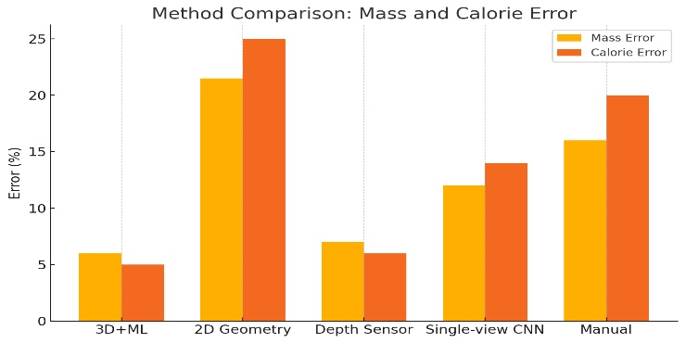

Figure 7: Method Comparison: Mass and Calorie Error

The error comparison on mass and calorie values compares the general performance of the various estimation methods. The error of the proposed 3D reconstruction with machine-learning-based density estimation is the lowest, which confirms that the use of geometric modelling and learned density is effective. Approaches based on depth sensors work effectively but require special equipment. Single-view depth CNNs are of moderate accuracy but have a problem of scale estimation. Manual measurement and 2D geometric approximation paint the worst picture as they prove to have the greatest errors and indicate that any simplistic or user-dependent shape assumption is not reliable, method comparison is shown in figure 7. Generally, the number supports the idea that the best calorie estimation is multi-view 3D reconstruction using ML density prediction.

Conclusion
The study provided an automated and holistic framework of estimating calories of fruits through a unified pipeline of fruit classification, 3D reconstruction, density prediction, and nutritional computation. The VGG19-based classification model was proposed to be 98 percent accurate, which allows identifying fruits with a high level of accuracy, which is the basis of the successful calorie count. The system successfully captured the geometry of objects with structure-from-Motion and depth-enhanced processing resulting in minimized error in the estimation of volume and perfect predictions of masses. Together with a Random Forest density model, which reached low prediction error, the whole system resulted in calorie estimates with much better accuracy of 4-6 percent which are significantly better than the old 2D and manual approximation methods. The effectiveness of combining computer vision and machine learning was proven by the results of experimental comparisons that show that the 3D+ML method can reduce the overall error by up to 25-40 percent. Its modular structure, resistance to fluctuation of lighting, and ability to integrate with mobile devices demonstrate the potential of the system in actual use in the fields of diet tracking, health monitoring, and even smart-kitchen ecosystems.
The future improvements can involve growth of the system to support mixed-food products, fruit salads, and cooked foods that possess complicated geometries. It may be possible to combine real-time monocular depth estimation when there is a need to have multi-view imagery. Accuracy could be further enhanced by density prediction by improving multimodal data, such as firmness, color analysis, or hyperspectral cues. Also, bigger and more varied datasets will be developed, and lightweight models will be used to support more embedded devices.

REFERENCES:

- P. T. Shanthala and D. Annapurna, “An improved IoT based security model for fitness tracker using quantum fruit fly optimization improved faster RCNN,” Int. J. Inf. Technol., vol. 15, no. 7, pp. 3623–3629, 2023, doi: 10.1007/s41870-023-01376-7.
- R. Wason, P. Arora, A. Tomar, and D. Arora, “A novel, low-cost, smart IoT based framework for fruit and vegetable quality detection during transit in India,” Int. J. Inf. Technol., vol. 15, no. 3, pp. 1509–1519, 2023, doi: 10.1007/s41870-023-01177-y.
- M. Vijayalakshmi and V. J. Peter, “CNN based approach for identifying banana species from fruits,” Int. J. Inf. Technol., vol. 13, no. 1, pp. 27–32, 2021, doi: 10.1007/s41870-020-00554-1.
- Trinh, Trung Hai, et al. “Mangosteen Fruit Detection Using Improved Faster R-CNN.” International Conference on Intelligence of Things. Cham: Springer International Publishing, 2022.
- X. Mai, Zhanf. H., Meng Q-H, “Faster R-CNN With Classifier Fusion for Automatic Detection of Small Fruits,” IEEE Transactions on Automation Science and Engineering, vol. 17, no. 12, pp. 1555–1569, 2020.
- S. Wan and S. Goudos, “Faster R-CNN for multi-class fruit detection using a robotic vision system,” Computer Networks 168, no. 11, p. 107036, 2020.
- Y. Zhan, Y. Chen, X. Li, M. Chen, and Z. Luo, “Fruit Recognition Based on Convolution Neural Network,” The 2020 second International Conference on Artificial Intelligence Technologies and Application (ICAITA) 2020 21-23 August 2020, Dalian, China, vol. 1651, no. 3, 2020.
- B. S. P, N. R, R. Y. R and H. R, “A Multi-Purpose Food Recognition System Using Convolutional Neural Network,” 2023 International Conference on Research Methodologies in Knowledge Management, Artificial Intelligence and Telecommunication Engineering, Chennai, India, 2023, pp. 1 - 5.
- G. Ramkumar, V. C. B, V. Manonmani, S. Palanivel, S. N and A. K. Kumar, “A Real-time Food Image Recognition System to Predict the Calories by Using Intelligent Deep Learning Strategy,” 2023 International Conference on RMKMATE, Chennai, India, 2023, pp. 1 - 7.
- J. Chen, B. Zhu, C. -W. Ngo, T. -S. Chua and Y. -G. Jiang, “A Study of Multi-Task and Region-Wise Deep Learning for Food Ingredient Recognition,” in IEEE Transactions on Image Processing, vol. 30, pp. 1514 - 1526, 2021.
- J. Jonathan, R. M. Benjamin and G. P. Prasad, “A Comprehensive Food Identification and Waste Reduction Solution with Built-in Nutritional Tracking using Machine Learning,” 2024 8th International Conference on Inventive Systems and Control (ICISC), Coimbatore, India, 2024, pp. 195 - 200.
- K. Fu, Y. Dai and Z. Zhu, “CNN-Based Visible Ingredients Recognition in a Food Image Using Decision Making Schemes,” 2023 IEEE International Conference on Systems, Man, and Cybernetics (SMC), Honolulu, Oahu, HI, USA, 2023, pp. 2427 - 2432.
- K. Moumane, I. El Asri, T. Cheniguer and S. Elbiki, “Food Recognition and Nutrition Estimation using MobileNetV2 CNN architecture and Transfer Learning,” 2023 14th International Conference on Intelligent Systems: Theories and Applications (SITA), Casablanca, Morocco, 2023, pp. 1 - 7.
- M. Haris, M. Sarim, V. Mishra and G. Singh, “FoodVisor: A Food Calorie Estimation System,” 2024 Second International Conference on Advances in Information Technology (ICAIT), Chikkamagaluru, Karnataka, India, 2024, pp. 1 - 7.
- M. Suneela, M. Sahithi, N. Vamsi, N. B. Naik and N. S. Chowdary, “Enhancing Dietary Monitoring using Deep Learning: Food Recognition and Calorie Estimation,” 2024 15th International Conference on Computing Communication and Networking Technologies (ICCCNT), Kamand, India, 2024, pp. 1 - 6.
- R. Krutik, C. Thacker and R. Adhvaryu, “Advancements in Food Recognition: A Comprehensive Review of Deep Learning-Based Automated Food Item Identification,” 2024 2nd International Conference on Electrical Engineering and Automatic Control (ICEEAC), Setif, Algeria, 2024, pp. 1 - 6.
- R. Sombutkaew and O. Chitsobhuk, “Image-based Thai Food Recognition and Calorie Estimation using Machine Learning Techniques,” 2023 20th International Conference on Electrical Engineering/Electronics, Computer, Telecommunications and Information Technology (ECTI-CON), Nakhon Phanom, Thailand, 2023, pp. 1 – 4
- S. S. Gaonkar and J. Sangeetha, “A Review: Food Recognition and Nutritional Value Estimation Using Deep Neural Network,” 2024 15th International Conference on Computing Communication and Networking Technologies (ICCCNT), Kamand, India, 2024, pp. 1 - 7.
- S. A. Ayon, C. Z. Mashrafi, A. B. Yousuf, F. Hossain and M. I. Hossain, “FoodieCal: A Convolutional Neural Network Based Food Detection and Calorie Estimation System,” 2021 National Computing Colleges Conference (NCCC), Taif, Saudi Arabia, 2021, pp. 1 - 6.

